# Phenology of flora of mediterranean high-mountains meadows (Sierra Nevada)

**Pérez-Luque, AJ**(1,2); **Sánchez-Rojas, CP**(3); **Zamora, R**(1,2); **Pérez-Pérez, R**(1,2); **Bonet, FJ**(1,2).

1 Laboratorio de Ecología (iEcolab), Instituto Interuniversitario de Investigación del Sistema Tierra en Andalucía (CEAMA), Universidad de Granada, Avenida del Mediterráneo s/n, 18006, Granada, Spain.

2 Grupo de Ecología Terrestre, Departamento de Ecología, Universidad de Granada, Facultad de Ciencias, Campus de Fuentenueva s/n, 18071, Granada, Spain

3 Agencia de Medio Ambiente y Agua de Andalucía. Consejería de Medio Ambiente y Ordenación del Territorio. Junta de Andalucía, C/ Joaquina Egüaras, 10, 18003, Granada, Spain

#### Corresponding author(s):

Antonio Jesús Pérez-Luque ([ajperez@ugr.es](mailto:ajperez@ugr.es)), Cristina Patricia Sánchez-Rojas ([cpsanchez@agenciamedioambienteyagua.es](mailto:cpsanchez@agenciamedioambienteyagua.es))

Received {date}; Revised {date}; Accepted {date}; Published {date}

#### Citation:

Combination of authors, year of data paper publication (in parentheses), Title, Journal Name, Volume, Issue number (in parentheses), and doi of the data paper.

#### Resource Citation

iEcolab, University of Granada-Andalusian Environmental Center (Andalusian Institute for Earth System Research) (2014) Phenology of flora of mediterranean high-mountains meadows (Sierra Nevada). 11004 data records. Contributed by University of Granada, OBSNEV, Agencia de Medio Ambiente y Agua de Andalucía, Sánchez-Rojas CP, Zamora R, Veredas A, Fuentes J, Bautista J, Onieva MR, Robles F, Arrufat M, Martínez M and the rangers of Sierra Nevada National-Natural Park B. Villagomez and D. Morillas. Online at <http://www.gbif.es:8080/ipt/resource.do?r=borreguiles> and <http://obsnev.es/noticia.html?id=7839>, version 1.0 (last updated on 2014-10-10). Resource ID: GBIF Key:

## Abstract

Sierra Nevada mountain range (southern Spain) hosts a high number of endemic plant species, being one of the most important biodiversity hotspots in the Mediterranean basin. The high mountain meadows ecosystems (“borreguiles”) harbor a large number of endemic and threatened plant species. In this datapaper we describe a dataset of the flora inhabiting this threated ecosystem in this mediterranean mountain. The dataset includes occurrences data of flora collected in those ecosystems in two periods: 1988-1990 and 2009-2013. A total of 11004 records of occurrences belonging to 20 orders, 29 families 52 genera were collected. 73 taxa were recorded with 29 threatened taxa. We also included data of cover-abundance and phenology attributes for the records. The dataset is included in the Sierra Nevada Global Change Observatory (OBSNEV), a long-term research project designed to compile socio-ecological information on the major ecosystem types in order to identify the impacts of global change in this area.

## Keywords

*Wet high-mountain meadows*, *abundance*, *phenology*, *Sierra Nevada (Spain)*, *long-term research*, *global change monitoring*, *occurrence*, *observation*.

## Project details

#### Project title:

Sierra Nevada Global Change Observatory (OBSNEV)

#### Personnel:

Regino Jesús Zamora Rodríguez (Scientific Coordinator, Principal Investigator, University of Granada); Francisco Javier Sánchez Gutiérrez (Director of the Sierra Nevada National Park and Natural Park).

#### Funding:

Sierra Nevada Global Change Observatory is funded by Andalusian Regional Government (via Environmental Protection Agency) and by the Spanish Government (via “Fundación Biodiversidad”, which is a Public Foundation).

#### Study area descriptions/descriptor:

Sierra Nevada (Andalusia, SE Spain), is a mountainous region with an altitudinal range between 860 m and 3482 m a.s.l. which covers more than 2000 km2 (Figure 1 a, b). The climate is Mediterranean, characterized by cold winters and hot summers, with pronounced summer drought (July-August). The annual average temperature decreases in altitude from 12-16ºC below 1500 m to 0ºC above 3000 m a.s.l., and the annual average precipitation is about 600 mm. Additionally, the complex orography of the mountains causes strong climatic contrasts between the sunny, dry south-facing slopes and the shaded, wetter north-facing slopes. Annual precipitation ranges from less than 250 mm in the lowest parts of the mountain range to more than 700 mm in the summit areas. Winter precipitation is mainly in the form of snow above 2000 m of altitude. The Sierra Nevada mountain range hosts a high number of endemic plant species (c. 80; Lorite et al. 2007) for a total of 2,100 species of vascular plants (25% and 20% of Spanish and European flora, respectively), being considered one of the most important biodiversity hotspots in the Mediterranean region (Blanca 1996; Blanca et al. 1998; Cañadas et al. 2014).

This mountain range has several legal protections: Biosphere Reserve MAB Committee UNESCO; Special Protection Area and Site of Community Importance (Natura 2000 network); and National Park. The area includes 61 municipalities with more than 90,000 inhabitants. The main economic activities are agriculture, tourism, cattle raising, beekeeping, mining, and skiing (Bonet et al. 2010).

#### Design description:

Sierra Nevada Global Change Observatory (OBSNEV) (Bonet et al. 2011) is a long-term research project which is being undertaken at Sierra Nevada Biosphere Reserve (SE Spain). It is intended to compile the information necessary for identifying as early as possible the impacts of global change, in order to design management mechanisms to minimize these impacts and adapt the system to new scenarios (Aspizua et al. 2010, Bonet et al. 2010). The general objectives are to:

* Evaluate the functioning of ecosystems in the Sierra Nevada Nature Reserve, their natural processes and dynamics over a medium-term timescale.
* Identify population dynamics, phenological changes, and conservation issues regarding key species that could be considered indicators of ecological processes.
* Identify the impact of global change on monitored species, ecosystems, and natural resources, providing an overview of trends of change that could help foster ecosystem resilience.
* Design mechanisms to assess the effectiveness and efficiency of management activities performed in the Sierra Nevada in order to implement an adaptive management framework.
* Help to disseminate information of general interest concerning the values and importance of Sierra Nevada.

The Sierra Nevada Global Change Observatory has four cornerstones:

1. A monitoring program with 40 methodologies that collect information on ecosystem functioning (Aspizua et al. 2012; 2014)
2. An information system to store and manage all the information gathered (<http://obsnev.es/linaria.html> - Pérez-Pérez et al. 2012; Free access upon registration)
3. A plan to promote adaptive management of natural resources using the knowledge amassed through the monitoring programme
4. An outreach program to disseminate all the available information to potential users (see News Portal of the project at <http://obsnev.es> and the wiki of the project at <http://wiki.obsnev.es>, Pérez-Luque et al. 2012)

The Sierra Nevada Global Change Observatory is linked to other national (Zamora and Bonet 2011) and international monitoring networks: GLOCHAMORE (Global Change in Mountain Regions) (Björnsen 2005), GLOCHAMOST (Global Change in Mountain Sites) (Schaaf 2009), LTER-Spain (Long-Term Ecological Research). CURRO METER AQUÍ LO DE EUBON

In addition to monitoring the ecosystems of this mountain range (i.e., collection of recent data from biotic and abiotic variables) the Sierra Nevada Global Change Observatory is incorporating historical information of biodiversity into its information system and some historical experiments and studies are being revisited to detect potential changes due to global change. The dataset described here is a good example of this idea: a singular ecosystem was revisited and resampled 30 years after to check if the phenology of its flora community has suffered changes.

#### Data published through GBIF:

<http://www.gbif.es:8080/ipt/resource.do?r=borreguiles>

### Taxonomic coverage

This dataset include records of phylum Magnoliophyta (10940 records, 99.41%) and marginally Pteridophyta (63 records, below 1 % of total records). Most of the records included in this dataset belong to both class Magnoliopsida (6057 records; 55.04 %) and Liliopsida (4883 records; 44.37 %). The class Psilotopsida is represented by 63 records. There are 19 orders represented in the dataset, being Poales (44.25 %) and Lamiales (12.52 %) the mosts important order from classes Liliopsida and Magnoliopsida respectively (Figure 2). Psilotopsida class is represented only by order Ophioglossales. In this collection, 28 families are represented, with Cyperaceae, Poaceae and Fabaceae being the families with major number of records (Figure 3). The dataset contains 72 taxa belonging to 51 genera. Carex, Nardus and Scorzoneroides are the most represented genera in the database. There are 29 threatened taxa (Table 1).

### Taxonomic ranks

***Kingdom:***Plantae

***Phylum:*** Magnoliophyta, Pteridophyta

***Class:***Liliopsida (Monocotyledones), Magnoliopsida (Dicotyledones), Psilotopsida

***Order:*** Apiales, Asterales, Asparagales, Boraginales, Brassicales, Caryophyllales, Celastrales, Ericales, Fabales, Gentianales, Lamiales, Liliales, Malpighiales, Myrtales, Ophioglossales, Poales, Ranunculales, Rosales, Saxifragales

***Family:*** Apiaceae, Asparagaceae, Asteraceae, Boraginaceae, Brassicaceae, Campanulaceae, Caryophyllaceae, Celastraceae, Crassulaceae, Cyperaceae, Ericaceae, Fabaceae, Gentianaceae, Juncaceae, Lentibulariaceae, Liliaceae, Linaceae, Onagraceae, Ophioglossaceae, Plantaginaceae, Poaceae, Portulacaceae, Polygonaceae, Ranunculaceae, Rosaceae, Rubiaceae, Scrophulariaceae, Violaceae

***Genus:*** Agrostis, Anthericum, Arenaria, Botrychium, Bromus, Campanula, Carex, Cerastium, Cirsium, Dactylis, Draba, Eleocharis, Epilobium, Erophila, Eryngium, Euphrasia, Festuca, Gagea, Galium, Gentiana, Gentianella, Herniaria, Juncus, Linaria, Lotus, Luzula, Meum, Montia, Myosotis, Nardus, Parnassia, Paronychia, Phleum, Pinguicula, Plantago, Poa, Potentilla, Radiola, Ranunculus, Rumex, Sagina, Scorzoneroides, Sedum, Silene, Spergularia, Stellaria, Thlaspi, Trifolium, Vaccinium, Veronica, Viola

### Spatial coverage

##### **General spatial coverage:**

Sierra Nevada is an isolated high mountain range (reaching 3.482 m.a.s.l.) located in Southern Spain (37ºN, 3ºW) covering 2.100 km2. It hosts a high number of vegetal endemic species (c. 80) (Lorite et al. 2007) in a total of 2.100 species of vascular plants (25 % and 20 % of Spain and Europe flora respectively), being considered one of the most important biodiversity hotspot in the Mediterranean region (Blanca et al. 1998). It has several legal protections: Biosphere Reserve MAB Committee UNESCO; Special Protection Area and Site of Community Importance (Natura 2000 network); and National Park. This mountain area comprises 27 habitats types from the habitat directive. It contains 31 fauna species (20 birds, 5 mammals, 4 invertebrates, 2 amphibians and reptiles) and 20 plants species listed in the Annex I and II of habitats and birds directives. There are 61 municipalities with more than 90.000 inhabitants. The main economic activities are agriculture, tourism, beekeeping, mining and skiing (Bonet et al. 2010).

#### Coordinates:

#### 36°52'12''N and 37°21'36''N Latitude; 3°41'24''W and 2°33'36''W Longitude

#### Temporal coverage

May 1988 - Oct 2013

#### 

#### Parent collection identifier: NA

##### **Collection name:**

##### Phenology of flora of mediterranean high-mountains meadows (Sierra Nevada)

##### **Collection identifier:**

db6cd9d7-7be5-4cd0-8b3c-fb6dd7446472 <http://www.gbif.es:8080/ipt/resource.do?r=borreguiles>

#### 

#### Methods

##### **Study extent description:**

The Mediterranean high-mountain meadows (know locally as “*borreguiles*”) are ecosystems conditioned by the snow dynamics and potentially sensitive to changes in water availability and temperature (Fernández Casas 1974; Martínez Parras et al. 1987). This ecosystem occupies an altitudinal range between 2200 and 3000 m a.s.l. and its distribution is determined by accumulation of the meltwater (Fernández-Casas 1974). Although it represents only 1.4% of this mountain range (1125 ha), it has a high rate of plant endemicity (Table 1) (Bonet et al. 2010; APMM 2013). The borreguiles is included in the Annex I of the Habitats Directive (EU habitat code 6230) (Bartolomé et al. 2005; Rigueiro et al. 2009). This ecosystem settles over hydromorphic soils that develop around mountain lakes, streams, depressions and glacier origin valleys. The overall appearance of borreguiles in summer is intense green, contrasting with the yellowish color of the surrounding psychroxerophiles grasslands (Figure 4).

This ecosystem contains several plant communities arranged as parallel bands in relation to natural water courses (Molero-Mesa 1999; Lorite 2002; Lorite et al. 2003) (Figure 4). The floristic composition of these communities depends on moisture content of the substrate. First, on some moist soil, as a transition from dry grasslands to borreguiles themselves, there is a medium coverage grassland called ***dry borreguil*** *(Armerio-Agrostietum nevadensis)*. It hosts species such *Agrostis nevadensis*, *Plantago nivalis*, *Ranunculus acetosellifolius, Thymus serpylloides* or *Arenaria tetraquetra* subsp. *amabilis* (among others) (Losa-Quintana et al. 1986; Lorite 2002). Then ***dense grassland*** appears, located in areas with constant moisture throughout the summer and deep soils. As typical species of this community (*Nardo-Festucetum ibericae*) include *Nardus stricta*, *Festuca iberica*, *Scorzoneroides microcephala*, *Lotus corniculatus subsp. glacialis,* *Luzula spicata*, *Ranunculus demissus* and *Campanula herminii*. Moreover, in the promontories areas appears a variation of the borreguil (*Ranunculo-Vaccinietum uliginosi*) which are enriched with the presence of *Vaccinium uliginosum* subsp. *nanum*. In places where there is constant flooding and still waters until fall, the optimum conditions of oxygen deprivation exist for ***incipient peat formations*** are installed. These communities (*Ranunculo-Caricetum intrincatae*) are characterized by the presence of species such as *Carex nigra*, *Eleocharis quinqueflora*, *C. echinata*, *C.* *nevadensis*, *Juncus articulatus*, *Ranunculus angustifolius, Pinguicula nevadensis* or *Festuca frigida*.

In addition to its high ecological value, this ecosystem plays an important role in transhumance livestock systems (Robles et al. 2009). They are pastures with a high nutritive value and with the greater forage production of the Sierra Nevada ecosystems (Boza et al. 2008; González-Rebollar 2006; Robles et al 2009, APMM 2013). This is important because they act as a trophic reserve for livestock in summer (Fernández-Casas 1974; Robles 2008). However the abandonment of uses linked this practice has tended effect of reducing the area of this ecosystems and consequent overloading of neighboring (González-Rebollar 2006; Robles 2008)

We selected one of the most representative borreguiles of Sierra Nevada, located at San Juan basin river (Guejar-Sierra; Granada, Spain) (Figure 1c). The catchment area is about 1325 Ha. and the basin was formed by glacial erosion of the bedrock (mica schists) and presents a valley with U-shaped (Martín Martín et al. 2010). This meadow, originated about 2000 years ago (Esteban 1996), occupies an area of 100 ha approximately.

##### **Sampling description:**

We sampled at three localities along an altitudinal gradient (Figure 5a): one at Prado de la Mojonera (Low Altitude; around 2200 m a.s.l.) and two at Hoya del Moro (Middle and High altitude; 2430-2550 m a.s.l. and around 2775 m a.s.l respectively). For each locality, the sampling was performed every 15 days during the free-snow period once a year from 1988-1990 and from 2009 to 2013. For the middle altitude locality we have data from two periods: 1988-1990 and 2009-2013. For low and high altitude locations we have data from 2009-2013 period.

In each locality permanent plots of 1 x 1 m were randomly distributed. In each plot a floristic inventory was carried out. The presence/absence and an estimation of abundance-coverage using the Braun-Blanquet cover-abundance scale (Braun-Blanquet 1964) were recorded for each taxa (Figure 5b). We also counted the number of individuals belong to three main phenological phase (phenophase) established: vegetative phenophase, reproductive phenophase (flowering) and seed phenophase. Plots were divided into quadrats of 25 x 25 cm to facilitate counting (Figure 5c) (Sánchez-Rojas 2012).

##### **Method step description:**

All data were stored in a normalized database and incorporated into the Information System of Sierra Nevada Global Change Observatory. Taxonomic and spatial validations were made on this database (see *Quality control description*). A custom-made SQL view of the database was performed to gather occurrence data and others variables associated to some occurence data, specifically:

* Flowering abundance: number of flowering individuals by square meter
* Fruit abundance: number of individuals in fruiting period by square meter
* Cover: the percentage of cover by taxon. The value represents a transformation of Braun-Blanquet cover-abundance scale (van der Maarel 1979; 2007)

The occurrence and measurement data were accommodated to fulfill the Darwin Core Standard (Wieczorek et al. 2009; 2012). We used Darwin Core Archive Validator tool (http://tools.gbif.org/dwca-validator/) to check whether the dataset meets Darwin Core specifications. The Integrated Publishing Toolkit (IPT v2.0.5) (Robertson et al. 2014) of the Spanish node of the Global Biodiversity Information Facility (GBIF) (http://www.gbif.es:8080/ipt) was used both to upload the Darwin Core Archive and to fill out the metadata.

The Darwin Core elements for the occurrence data included in the dataset are: occurrenceId, modified, basisOfRecord, institutionCode, collectionCode, catalogNumber, occurrenceRemarks, scientificName, kingdom, phylum, class, order, family, genus, specificEpithet, infraspecificEpithet, scientificNameAuthorship, continent, country, stateProvince, county, locality, minimumElevationInMeters, maximumElevationInMeters, recordedBy, identifiedBy, dateIdentified, decimalLongitude, decimalLatitude, coordinateUncertaintyinMeters.

For the measurement data, the Darwin Core elements included are: id, measurementID, measurementType, measurementValue, measurementAccuracy, measurementUnit, measurementDeterminedDate, measurementDeterminedBy, measurementMethod, measurementRemarks.

##### **Quality control description:**

The sampling plots were georeferenced using a Garmin eTrex Legend GPS (ED1950 Datum) with an accuracy of ±5 m. We also used colour digital ortophotographs provided by the Andalusian Cartography Institute and GIS (ArcGIS 9.2; ESRI, Redlands, California, USA) to verify that the geographical coordinates of each sampling plots were correct (Chapman and Wieczorek 2006).

The specimens were taxonomically identified using *Flora Iberica* (Castroviejo et al. 1986-2005; Castroviejo 2001) and others reference floras: *Flora de Andalucía Oriental* (Blanca et al. 2011), *Flora Vascular de Andalucía Oriental* (Valdés et al. 1987) and *Flora Europaea* (Tutin et al. 1964–1980). The scientific names were checked with databases of International Plant Names Index (IPNI 2013) and Catalogue of Life/Species 2000 (Roskov et al. 2013). We also used the R packages taxize (Chamberlian and Szocs 2013; Chamberlain et al. 2014) and Taxostand (Cayuela and Oksanen 2014) to verify the taxonomical classification.

We also performed validation procedures (Chapman 2005a; 2005b) (geopraphic coordinate format, coordinates within country/provincial boundaries, absence of ASCII anomalous characters in the dataset) with DARWIN_TEST (v3.2) software (Ortega-Maqueda and Pando, 2008).

#### Dataset description

##### **Object name:**

Darwin Core Archive Phenology of flora of mediterranean high-mountains meadows (Sierra Nevada)

##### **Character encoding:** UTF-8

##### **Format name:** Darwin Core Archive format

##### **Format version:** 1.0

***Distribution:***<http://www.gbif.es:8080/ipt/resource.do?r=borreguiles>

##### **Publication date of data:** 2014-04-29

##### **Language:** English

##### **Licenses of use:** The Phenology of flora of mediterranean high-mountains meadows (Sierra Nevada) dataset is made available under the Open Data Commons Attribution License: http://www.opendatacommons.org/licenses/by/1.0

##### **Metadata language:** English

**Date of metadata creation:** 2014-11-18

**Hierarchy level:** Dataset

#### Acknowledgements

This research work was conducted in the collaborative framework of the “Sierra Nevada Global Change Observatory” Project funded the Environment Department of Andalusian Regional Government and the Sierra Nevada National Park. We thank to the support staff of the Agencia de Medio Ambiente y Agua de Andalucía, rangers of the Sierra Nevada National and Natural Park, and research fellows (University of Granada) who participated in the data collection. We also thank to Katia Cezón and Franciso Pando (Spanish GBIF node–CSIC) for technical support. We thank David Nesbitt for linguistic advice. Thanks to José M. Martín-Martín (University of Granada) who provided permission to reproduce the picture included in figure 4. A. J. Pérez-Luque would like to thank the MICINN of the Government of Spain for the financial support (PTA 2011-6322-I)

#### References

APMM (Asociación Pastores por el Monte Mediterráneo) (2013). Ganadería Extensiva y PAC en Andalucía. Un análisis con propuestas para el futuro. Asociación Pastores por el Monte Mediterráneo and European Forum on Nature Conservation and Pastoral. Available at [www.pastoresmonte.org/dl94](http://www.pastoresmonte.org/dl94)

Aspizua R, Bonet FJ, Zamora R, Sánchez FJ, Cano-Manuel FJ, Henares I (2010) El observatorio de cambio global de Sierra Nevada: hacia la gestión adaptativa de los espacios naturales. Ecosistemas 19 (2): 56–68. <http://www.revistaecosistemas.net/index.php/ecosistemas/article/view/46>

Aspizua R, Barea-Azcón JM, Bonet FJ, Pérez-Luque AJ, Zamora R (Eds) (2012) Observatorio de Cambio Global Sierra Nevada: metodologías de seguimiento. Consejería de Medio Ambiente, Junta de Andalucía, 1–112.

Aspizua R, Barea-Azcón JM, Bonet FJ, Pérez-Luque AJ, Zamora RJ (2014) Sierra Nevada Global-Change Observatory. Monitoring methodologies. Consejería de Medio Ambiente, Junta de Andalucía, 112 pp. Available at <http://refbase.iecolab.es/files/aspizua/2014/2714_Aspizua_etal2014.pdf>

Bartolomé C, Álvarez-Jiménez J, Vaquero J, Costa M, Casermeiro MA, Giraldo J, Zamora J (2005) Los tipos de hábitats de interés comunitario de España. Ministerio de Medio Ambiente. Madrid

Björnsen A (Ed) (2005) The GLOCHAMORE (Global Change and Mountain Regions) Research Strategy. Berne (Switzerland) and Vienna (Austria). Mountain Research Initiative Office and University of Vienna, 1– 48. <http://unesdoc.unesco.org/images/0014/001471/147170E.pdf>

Blanca G (1996) Protección de la flora de Sierra Nevada (Granada y Almería). Conservación Vegetal 1: 6

Blanca G, Cueto M, Martínez-Lirola MJ, Molero-Mesa J (1998) Threatened vascular flora of Sierra Nevada (Southern Spain). Biological Conservation 85 (3): 269-285. doi: [10.1016/S0006-3207(97)00169-9](http://dx.doi.org/10.1016/S0006-3207(97)00169-9)

Blanca G, Ruíz-Rejón M, Zamora R (1999) Taxonomic revision of the genus Pinguicula L. in the Iberian Peninsula. Folia Geobotanica 34(3): 337–361.

Blanca G, López Onieva MR, Lorite J, Martínez Lirola MJ, Molero Mesa J, Quintas S, Ruíz-Girela M, Varo MA, Vidal S (2001) Flora amenazada y endémica de Sierra Nevada. Editorial Universidad de Granada. Granada. 410 pp.

Blanca G, Cabezudo B, Cueto M, Fernández-López C, Morales-Torres C (Eds) (2011) Flora Vascular de Andalucía Oriental. Consejería de medio Ambiente, Junta de Andalucía, Sevilla.

Bonet FJ, Pérez-Luque AJ, Moreno R, Zamora R (2010) Sierra Nevada Global Change Observatory. Structure and Basic Data. Environment Department (Andalusian Regional Government)–University of Granada, 1–48. <http://refbase.iecolab.es/files/bonet/2010/2905_Bonet_etal2010.pdf>

Bonet FJ, Aspizua-Cantón R, Zamora R, Sánchez FJ, Cano-Manuel FJ, Henares I (2011) Sierra Nevada Observatory for monitoring global change: Towards the adaptive management of natural resources. In: Austrian MaB Comitee (Ed) Biosphere Reserves in the mountains of the world. Excellence in the clouds?. Austrian Academy of Sciences Press, Vienna: 48-52.

Boza J, Robles AB, González-Rebollar JL (2007) El papel de la ganadería en las zonas áridas de Andalucía. In Rodero Franganillo A, Rodero Serrano E (Eds) La ganadería Andaluza en el siglo XXI. Patrimonio Ganadero Andaluz. Volumen I. Consejería de Agricultura y Pesca. Junta de Andalucía, 241–266.

Braun-Blanquet J (1964) Pflanzensoziologie. Springer Verlag, Wien, New York, 1 – 865.

Cabezudo B, Talavera S, Blanca G, Salazar C, Cueto M, Valdés B, Hernández-Bermejo JE, Herrera CM, Rodríguez-Hiraldo C, Navas D (2005) Lista roja de la flora vascular de Andalucía. Junta de Andalucía, Consejería de Medio Ambiente; Sevilla, Spain.

Cañadas EM, Fenu G, Peñas J, Lorite J, Mattana E, Bacchetta G (2014) Hotspots within hotspots: Endemic plant richness, environmental drivers, and implications for conservation. Biological Conservation 170: 282–291 doi: [10.1016/j.biocon.2013.12.007](http://dx.doi.org/10.1016/j.biocon.2013.12.007)

Castroviejo S (Ed) (1986–2005) Flora Iberica. Real Jardín Botánico CSIC, Madrid.

Castroviejo S (Ed) (2001) Claves de Flora Ibérica. Plantas Vasculares de la Península Ibérica e Islas Baleares. Volumen 1. Consejo Superior de Investigaciones Científicas. Real Jardín Botánico, Madrid.

Cayuela L, Oksanen J (2014) Taxonstand: Taxonomic standardisation of plant species names. R package version 1.3. <http://CRAN.R-project.org/package=Taxonstand>

Chamberlain SA, Szöcs E (2013) taxize: taxonomic search and retrieval in R. F1000Research 2: 191. doi: [10.12688/f1000research.2-191.v2](https://dx.doi.org/10.12688/f1000research.2-191.v2)

Chamberlain S, Szocs E, Boettiger C, Ram K, Bartomeus I, Baumgartner J (2014) taxize: Taxonomic information from around the web. R package version 0.3.0. <https://github.com/ropensci/taxize>

Chapman AD (2005a) Principles and Methods of Data Cleaning – Primary Species and Species-Occurrence Data, version 1.0. Global Biodiversity Information Facility, Copenhagen, 75 pp. <http://www.gbif.org/orc/?doc_id=1262>

Chapman AD (2005b) Principles of Data Quality, version 1.0. Global Biodiversity Information Facility, Copenhagen, 61 pp. <http://www.gbif.org/orc/?doc_id=1229>

Chapman AD, Wieczorek J (2006) Guide to Best Practices for Georeferencing. Copenhagen: Global Biodiversity Information Facility. Available online at <http://www.gbif.org/orc/?doc_id=1288>

EC (1992) Council Directive 92/43/EEC of 21 May 1992 on the conservation of natural habitats and of wild fauna and flora. Official Journal L 206: 7–50. <http://eur-lex.europa.eu/LexUriServ/LexUriServ.do?uri=CELEX:31992L0043:EN:HTML>

Esteban A (1996) Evolución del paisaje nevadense durante los últimos 1.500 años a partir del análisis polínico de borreguiles. 1ª Conferencia Internacional Sierra Nevada. Universidad de Granada. Granada, vol. IV. pp. 251-273.

Fernández-Casas J (1974). Vegetación y flora de Sierra Nevada. Los borreguiles. Boletín de la Estación Central de Ecología, 3: 29–42.

González-Rebollar JL (2006) Caracterización, análisis y dinámica de los sistemas silvopastorales del Parque Nacional de Sierra Nevada. Organismo Autónomo Parques Nacionales. Ministerio de Medioambiente. 2003-2006.

IPNI (2013) The International Plant Names Index. <http://www.ipni.org> [accessed 05.08.2014]

IUCN (2001) IUCN Red List Categories. Prepared by the IUCN Species Survival Commission. As approved by the 51st Meeting of the IUCN Council Gland, Switzerland. UICN, Gland, Switzerland.

Lorite J (2001). Vegetación de Sierra Nevada. Pp.: 23-45. In: Blanca G, López Onieva MR, Lorite J, Martínez Lirola MJ, Molero Mesa J, Quintas S, Ruíz-Girela M, Varo MA, Vidal S (Eds) Flora amenazada y endémica de Sierra Nevada. Editorial Universidad de Granada. Granada. 410 pp.

Lorite J, Valle F, Salazar C (2003) Síntesis de la vegetación edafohigrófila del Parque Natural y Nacional de Sierra Nevada. Monografías Flora y Vegetación Béticas 13: 47–110

Lorite J, Navarro FB, Valle F (2007) Estimation of threatened orophytic flora and priority of its conservation in the Baetic range (S. Spain). Plant Biosystems 141 (1): 1-14. doi: [10.1080/11263500601153560](https://dx.doi.org/10.1080/11263500601153560)

Losa Quintana JM, Molero-Mesa J, Casares Porcel M, Pérez-Raya F (1986) El paisaje vegetal de Sierra Nevada: la cuenca alta del Río Genil. Servicio de Publicaciones de la Universidad de Granada, Granada. 285 pp.

Martín-Martín JM, Braga JC, Gómez-Pugnaire MT (2010) Itinerarios geológicos por Sierra Nevada. Consejería de Medio Ambiente. Junta de Andalucía.

Martínez-Parras, J.M.; Peinado, M. & Alcaraz, F. (1987). Datos sobre la vegetación de Sierra Nevada. Lazaroa, 7: 515–533.

Molero-Mesa J (1999) The vegetation of Sierra Nevada. Itinera Geobotanica 13: 105–118.

Moreno JC (coord.) (2010) Lista Roja 2008 de la flora vascular española. Actualización con los datos del Adenda 2010 al Atlas y Libro Rojo de la Flora Vascular Amenazada. Dirección General de Medio Natural y Política Forestal (Ministerio de Medio Ambiente, y Medio Rural y Marino, y Sociedad Española de Biología de la Conservación de Plantas). Madrid. 46 pp.

Ortega-Maqueda I, Pando F (2008) DARWIN_TEST v3.2: Una aplicación para la validación y el chequeo de los datos en formato Darwin Core 1.2 or Darwin Core 1.4. Unidad de Coordinación de GBIF.ES, CSIC. Ministerio de Educación y Ciencia. Madrid, Spain, <http://www.gbif.es/Darwin_test/Darwin_test.php>

Pérez-Luque AJ, Bonet FJ, Zamora R (2012) The Wiki of Sierra Nevada Global Change Observatory. Bulletin of the Ecological Society of America 93(3): 239–240. doi: [10.1890/0012-9623-93.3.239](http://dx.doi.org/10.1890/0012-9623-93.3.239)

Pérez-Pérez R, Bonet FJ, Pérez-Luque AJ, Zamora R (2012) Linaria: a set of information management tools to aid environmental decision making in Sierra Nevada (Spain) LTER site. In: Long Term Ecological Research (LTER) (Ed) Proceedings of the 2013 LTER All Scientist Meeting: The Unique Role of the LTER Network in the Antropocene: Collaborative Science Across Scales. LTER, Estes Park - Colorado (EE.UU)

Rigueiro A, Rodríguez MA, Gómez-Orellana L (2009) 6230 Formaciones herbosas con Nardus, con numerosas especies, sobre sustratos silíceos de zonas montañosas (y de zonas submontañosas de Europa continental). In: VVAA (Ed) Bases ecológicas preliminares para la conservación de los tipos de hábitat de interés comunitario en España. Ministerio de Medio Ambiente, y Medio Rural y Marino, Madrid, 66 pp.

Robertson T, Döring M, Guralnick R, Bloom D, Wieczorek J, Braak K, Otegui J, Russell L, Desmet P (2014) The GBIF Integrated Publishing Toolkit: Facilitating the Efficient Publishing of Biodiversity Data on the Internet. PLoS ONE 9(8): e102623EP, doi: [10.1371/journal.pone.0102623](https://dx.doi.org/10.1371/journal.pone.0102623)

Robles, AB (2008) En el conjunto de las Sierras Béticas: pastos, producción, diversidad y cambio global. In: Fernández-Rebollo P, Gómez-Cabrera A, Guerrero JE, Garrido-Varo A, Calzado C, García-Romero AM, Carbonero MD, Blázquez A, Escuín S, Castilo-Carrión S (Eds) Pastos, clave en la gestión de los territorios: integrando disciplinas. Sociedad Española para el Estudio de los Pastos. Consejería de Agricultura y Pesca. Junta de Andalucia. 31–51.

Robles AB, Ruiz-Mirazo J, Ramos ME, González-Rebollar JL (2009) Role of livestock grazing in sustainable use, naturalness promotion in naturalization of marginal ecosystems of southeastern Spain (Andalusia). In: Rigueiro-Rodríguez A, McAdam J, Mosquera-Losada MR (Eds) Agroforestry in Europe: current status and future prospects. Springer, 211–231.

Roskov Y, Kunze T, Paglinawan L, Abucay L, Orrell T, Nicolson D, Culham A, Bailly N, Kirk P, Bourgoin T, Baillargeon G, Hernandez F, De Wever A, Didžiulis V (Eds) (2013) Species 2000 & ITIS Catalogue of Life. Species 2000: Reading, UK. <http://www.catalogueoflife.org/col> [accessed 08.05.2014]

Sánchez-Rojas CP (2012) Pastos húmedos de alta montaña: borreguiles. In: Aspizua R, Barea-Azcón JM, Bonet FJ, Pérez-Luque AJ, Zamora R (Eds) Observatorio de Cambio Global Sierra Nevada: metodologías de seguimiento. Consejería de Medio Ambiente, Junta de Andalucía, 72–73.

Sánchez-Gutiérrez J, Pino J (coord) (2004) Guía de visita del Parque Nacional de Sierra Nevada. Organismo Autónomo Parques Nacionales. 296 p.

Schaaf T (2009) Mountain Biosphere Reserves–A People Centred Approach that also Links Global Knowledge. Sustainable Mountain Development 55: 13–15. <http://lib.icimod.org/record/26505/files/c_attachment_601_5624.pdf>

Tutin TG et al. (Eds) (1964–1980) Flora Europaea, Cambridge University Presss, Cambridge, 1–5.

Valdés B, Talavera S, Fernández-Galiano E (Eds) (1987) Flora vascular de Andalucía Occidental, 1–3. Ketres, Barcelona.

van der Maabel E (1979) Transformation of cover-abundance values in phytosociology and its effects on community similarity. Vegetatio 39(2): 97–114. doi: [10.1007/BF00052021](https://dx.doi.org/10.1007/BF00052021)

van der Maarel E (2007) Transformation of cover-abundance values for appropriate numerical treatment – Alternatives to the proposals by Podani. Journal of Vegetation Science 18(5): 767–770. doi: [10.1111/j.1654-1103.2007.tb02592.x](https://dx.doi.org/10.1111/j.1654-1103.2007.tb02592.x)

Wieczorek J, Döring M, De Giovanni R, Robertson T, Vieglais D (2009) Darwin Core Terms: A quick reference guide. <http://rs.tdwg.org/dwc/terms/> [accessed 17.10.2014].

Wieczorek J, Bloom D, Guralnick R, Blum S, Döring M, Giovanni R, Robertson T, Vieglais D (2012) Darwin Core: An evolving community-developed biodiversity data standard. PLoS ONE 7(1): e29715EP, doi: [10.1371/journal.pone.0029715](https://dx.doi.org/10.1371/journal.pone.0029715)

Zamora R (1990a) Observational and experimental study of a carnivorous plant-ant kleptobiotic interaction. Oikos 59(3): 368–372

Zamora, R. (1990b). The feeding ecology of a carnivorous plant (*Pinguicula nevadense*): prey analysis and capture constraints. *Oecologia*, 84 (3): 376–379

Zamora R, Bonet FJ (2011) Programa de Seguimiento del Cambio Global en Sierra Nevada: ciencia y tecnología para la gestión adaptativa. Boletín de la RED de seguimiento del cambio global en Parques Nacionales, 1: 18–24. <http://reddeparquesnacionales.mma.es/parques/rcg/html/rcg_boletin_01.htm>

Figure 1. Location of Sierra Nevada (souhter Spain) and boundaries of the National and Natural Parks (top panels). The bottom panel shows the location of the borreguiles at San Juan basin river with the sampling plots along an altitudinal gradient.

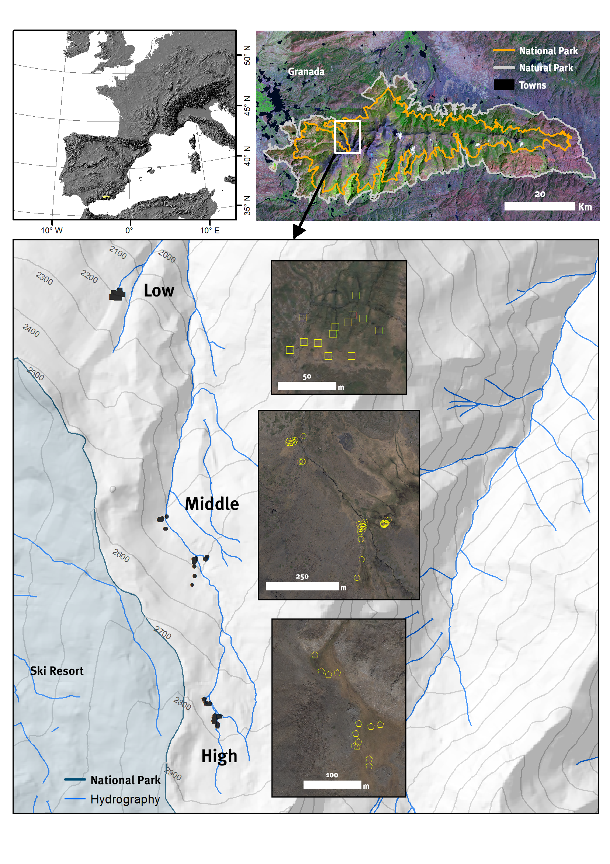

Figure 2. Taxonomic coverage. The upper bar shows the percentage of records of the dataset belonging to each phylum. The bottom bars show the percentage of total records in the dataset by order. The number of records is included above the bars. The order bars is aggregated by class.

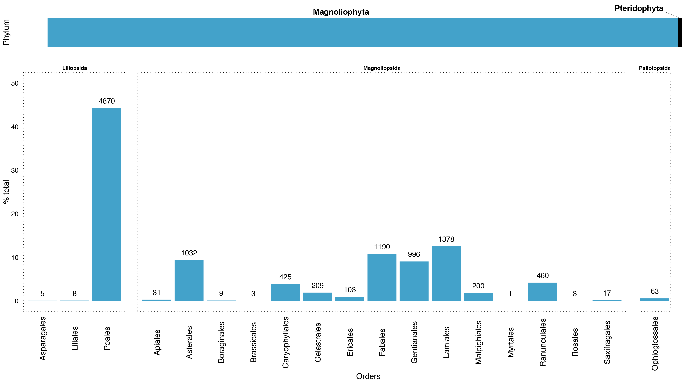

Figure 3. Taxonomic coverage (families). Percentage of dataset records by families. The numbers indicate the records of each family.

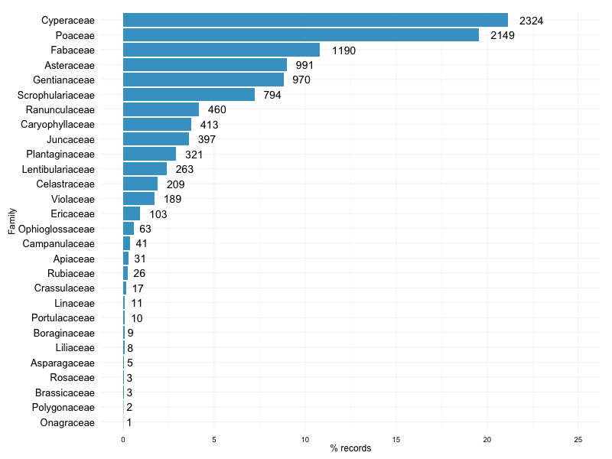

Figure 4. ***(a)*** Panoramic view of the borreguil installed at San Juan valley. The particular zonation of this ecosystem depending on soil moisture is reflected in the different colors of the borreguil. ***(b)*** Schematic representation of the vegetal communities forming the borreguiles, including *dry borreguil* (*4:* *Armerio-Agrostietum nevadensis*), *dense grassland* (*1: Nardo-Festucetum ibericae*), *incipient peat formations* (*2: Ranunculo-Caricetum intrincatae*) and variants of borreguil in promontories areas (*3: Ranunculo-Vaccinietum uliginosi*). Modified from Losa-Quintana et al. (1986).

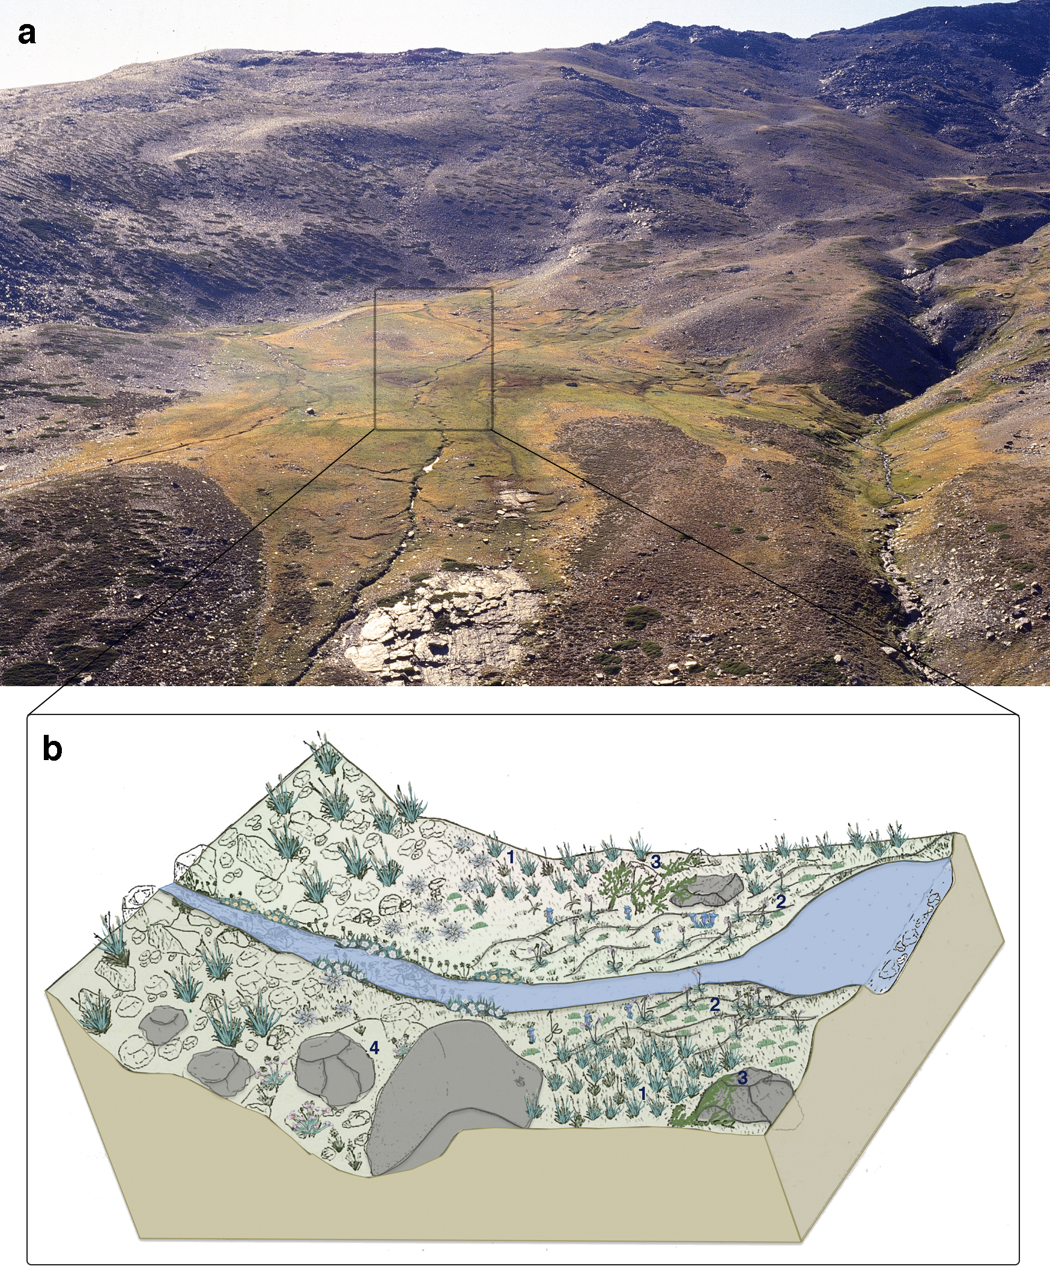

Figure 5. Schema of the sampling design. ***a)*** Different sampling plots were distributed along an altitudinal gradient. For the middle altitude locality the plots were sampled in two periods: 1988-1990 and 2009-2013*.* View of a sampling plot of 1 x 1 m (***b***) that was divided into quadrats of 25 x 25 cm to facilitate counting (***c***) and to record the cover-abundance and the number of individuals in flowering (***d***) or in fruit phenophase.

